Emergency Fax

I am disabled

I cannot speak

I cannot hear

Who is sending this fax?

Name:________________________________ Your Fax Number:_____________________
Where do you need help?

Street Address:____________________Apt./Room No.____________ Floor:_________

City or location_ ____________________________________________________________

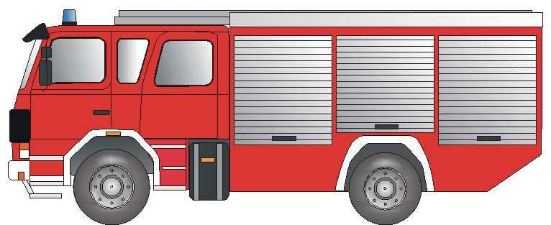
What kind of help?
What is happening?

______________________________________________________________________________________________________________________________________________________________________________________________________________________________________
Fire Department Fire Rescue Accident



Ambulance Paramedic Injury Illness



POLIZEI

Police Break-In/ Assault Violencei

Thank you! Your Signature:_____________________________

Please fax back! Bitte zurückfaxen! Bitte zurückfaxen! Please fax back!

We have received your emergency fax and ______________________________________________

is on the way to your location. Signature of Receiving Dispatcher: _____________________________
Ein Service der BD Frankfurt am Main und dem Deutschen Schwerhörigenbund e. V. – Referat „Barrierefreies Planen und Bauen“/2011

